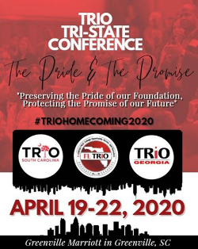

2020 TRIO Achiever’s Cover Letter

Tri- State Spring Conference

Florida, Georgia & South Carolina TRIO Programs

Dear TRIO Colleague:

As you all know, the celebration of TRIO Achievers is a way to publicly recognize outstanding former TRIO Program participants. It gives us the opportunity to congratulate the TRIO Achievers on their success and thank them for their inspiration. The awards further serve as a source of pride as they demonstrate the success of TRIO in making a difference in thousands of lives. These men and women have distinguished themselves and are making positive contributions in their chosen professions. We encourage you to nominate former TRIO Program participants who you feel are appropriate for this award. The deadline for 2020 TRIO Achiever nominations is March 15, 2020.

Criteria for Selection of TRIO Achievers
- The TRIO Achiever candidate must be a former TRIO project participant who was enrolled in and successfully completed a TRIO program.
- The TRIO Achiever candidate must have enrolled in and successfully completed a postsecondary program of study.
- The TRIO Achiever candidate must be a person of high stature within his/her profession or who has received recognition for outstanding academic achievement.
- Participation in the TRIO project must have had significant impact upon the candidate in obtaining his/her educational and/or professional objectives (as acknowledged in a personal statement). • The person nominating the achiever must be a current member of FAEOPP, GASPP or
- SC TRiO
- The achiever’s information packet must be emailed to the chairperson of the 2020 Tri- State TRIO Achievers’ Committee on or before the deadline of. March 15, 2020.

Nomination Procedures
Please email the following in addition to the nomination form:
  - Electronic Photo of Nominee (Required)
  - Testimonial Letter from Nominator
  - Personal Statement from Nominee (not to exceed 300 words)
  - Nominee’s Resume

Submit complete nomination packet to:
2020 Tri-State TRIO Achievers’ Committee

Florida: Cherry Stallworth cherry.stallworth@fscj.edu
Georgia: Holly Lawrence hmlawrence@valdosta.edu
South Carolina: Dorlisa Damon damond@mailbox.sc.edu

NOMINEES FROM EACH STATE WILL BE HONORED. COMMITTEE WILL SELECT THE HONOREES FROM AMONG THE CANDIDATES SUBMITTED.

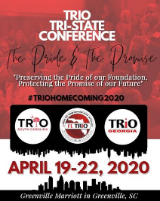

2020 TRIO Achievers Nomination Form
Tri-State Spring Conference
Florida, Georgia & South Carolina TRIO Programs

NOMINEE:
______________________________________________________________________________________
FIRST NAME MIDDLE NAME LAST NAME

______________________________________________________________________________________
NOMINEE PARTICIPATED IN: TRIO PROJECT INSTITUTION

FROM (month/day/year): ______/ ______/_____ to ______/ ______/_____

______________________________________________________________________________________
TYPE OF DEGREE/FIELD OF STUDY INSTITUTION YEAR DEGREE(S) RECEIVED

______________________________________________________________________________________
TYPE OF DEGREE/FIELD OF STUDY INSTITUTION YEAR DEGREE(S) RECEIVED

HOME ADDRESS: EMPLOYER:
_______________________________________ ____________________________________ STREET ADDRESS OR P.O. BOX STREET ADDRESS OR P.O. BOX
_______________________________________ |  | ____________________________________
CITY STATE ZIP |  | CITY STATE ZIP
_______________________________________ |  | ____________________________________
PHONE FAX |  | PHONE FAX
_______________________________________ |  | ____________________________________
EMAIL |  | EMAIL

NOMINATED BY:
______________________________________________________________________________________
FIRST NAME LAST NAME
______________________________________________________________________________________
INSTITUTION
______________________________________________________________________________________
STREET ADDRESS OR P.O. BOX CITY STATE ZIP
______________________________________________________________________________________
PHONE FAX EMAIL

SUPPORTING DOCUMENTATION
SUBMISSION DEADLINE: March 15, 2020

Please submit with this form:
- Electronic Photo of Nominee (Required)
- Testimonial Letter from Nominator
- Personal Statement from Nominee (not to exceed 300 words)
- Nominee’s Resume

TRIO Achiever’s Breakfast Wednesday, April 22,2020 9:00 AM-11:00 AM
Greenville Marriott
One Parkway E
Greenville, South Carolina

2020 TRIO Achiever’s Personal Statement from Nominee Tri- State Spring Conference Florida, Georgia & South Carolina TRIO Programs

Please indicate how participation in a TRIO program had an impact on your educational and/or professional objectives. To the extent warranted or deemed necessary, you may include aspects of your background that occurred prior to participating in the program. (Your essay must be between 250-300 words).

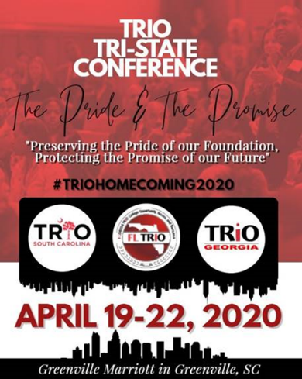

2020 TRIO Achiever’s Resume Tri- State Spring Conference Florida, Georgia & South Carolina TRIO Programs

Please provide a concise statement in resume or narrative form which summarizes your educational background; professional employment; academic and/or professional honors; professional, community or civic contributions; and other such information that you deem pertinent to your nomination for the TRIO Achiever Award. (Two Page Limit)

2020 TRIO Achiever’s Testimonial Letter from Nominator Tri- State Spring Conference
Florida, Georgia & South Carolina TRIO Programs

Applicant’s Name

The individual named above has indicated that you would provide a letter of recommendation in support of his/her application for the 2019 Tri-State TRIO Achiever Award. Please indicate in what capacity and to what extent you are familiar with the applicant’s academic background; professional employment; professional, community and/or civic contributions; honors or awards received; and other such information that you deem pertinent to the nomination of this individual for a Tri-State TRIO Achiever Award. (Two Page Limit)

2019 TRIO Achiever’s Electronic Photo Tri- State Spring Conference
Florida, Georgia & South Carolina TRIO Programs

Electronic Photo

