2021 Tri-State Conference Vendor Packet

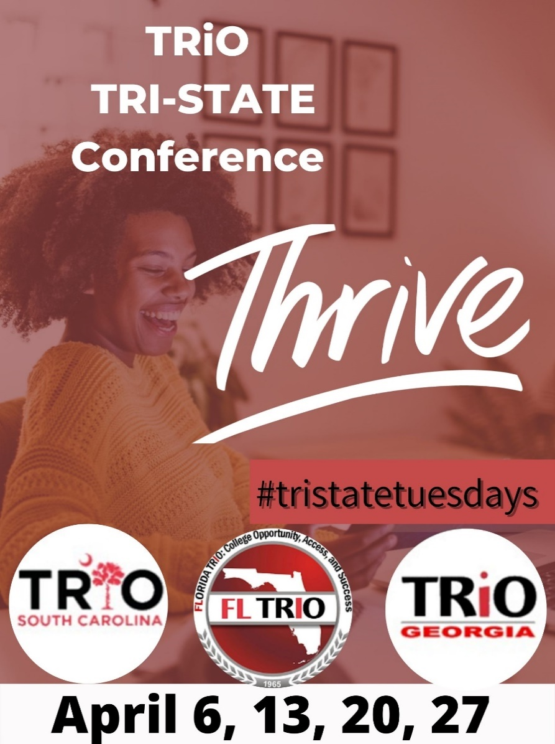

2021 Tri-State Conference
Virtual Vendor Packet

Dear Prospective Virtual Vendor,

The annual Tri-State Conference of the Florida, Georgia and South Carolina TRIO programs is an established forum for employees of the Federal TRIO programs to come together to share information and network about equal educational opportunity and access to postsecondary education. We are pleased to offer you the opportunity to market your products and services to individuals who administer federal grant programs that promote college access and educational opportunity.
This year’s conference will convene on Tuesdays in April (6th, 13th, 20th) 2021 via a virtual platform. We have dubbed these series of meeting as “Tri-State Tuesdays”. We are expecting upwards of 250+ registrants to be in attendance this year. These attendees represent $10,000 - $20,000 per program in purchasing power. This conference will afford you the best possible exposure to an audience uniquely focused on academic, career and guidance services and products for students at the secondary and post- secondary levels of education. We hope your organization or company will join us in making our Tri-State Tuesdays a success!
We will also provide a unique opportunity for our virtual vendors to raffle off items to bring about awareness of their products and services as well as to assist us with our various fund-raising efforts to include our fair share initiative. Our goal is to ensure that you are well promoted and that your support for our event is widely advertised amongst attendees.
A copy of the 2021 Virtual Vendor Prospectus and Agreement is attached.
Please mail your check with a copy of your completed contract to the perspective State Treasurer (as listed on the Advertisement Form).

VIRTUAL VENDORS PROSPECTUS

EVENT LOCATION: VIRTUAL

VENDOR PACKAGE INCLUSIONS: $350.00
- Vendor Plenary Sponsorship (Ad on display during 1 plenary)
- Full Page Program Booklet Ad (Duration of Conference)
- Attendee List
- Hospitality Event Advertising
*All events are virtual

VENDING SCHEDULE

Tri-State Tuesdays
- April 06, 2020
- April 13, 2020
- April 20, 2020

RESERVE YOUR PACKAGE EARLY & THRIVE!

VENDOR’S AGREEMENT
2021 Virtual Tri-State Conference
April 6,13,20, 2021

FIRST NAME: |  | LAST NAME:
COMPANY/AGENCY:
ZIP CODE: | CITY: |  | STATE:
E-MAIL ADDRESS: | OFFICE PHONE NUMBER: |  | CELL PHONE NUMBER:
As an exhibitor representing , (Name of Company/Agency)

I hereby agree to provide a continuous exhibit during the 2021Professional Development Conference sponsored by the Florida TRIO, Georgia TRIO, South Carolina Trio. Further, I agree to indemnify and hold harmless “Florida TRIO, Georgia TRIO, and South Carolina TRIO” for any claims whatsoever occasioned
in any situation and warrant that “Florida TRIO, Georgia TRIO, South Carolina TRIO” shall not be held liable for any illegible/errant media content submitted by the proposed Vendor. Cancellation/Refund Policy: No Refund shall be issued under any circumstances with the exception of event cancellation by the host party, i.e. Florida TRIO, Georgia TRIO, or South Carolina TRIO.

(Signature of Representative) (Date)

All exhibitors should forward Ads to Vendor Committee Chair @ antonio.robinson@tridenttech.edu . Tri-State Conference will NOT be responsible for Ad edits, changes, or imperfections.

Note: Please see information below payment submissions.

2021 Tri-State Conference Advertisement Form

Please complete the following information to submit an advertisement for the 2021 Tri-State Conference Booklet.

Name of company/agency/program Contact person Email: Phone # _
Address City State Zip Code Method of Payment
Vendor Package Payments:
Invoices will be sent within 48 hours of registration.

For additional payment questions, please contact our treasurer using the information below.

Lawanna Hair, Treasurer
lmhair@usf.edu
813.270.3002
PACKAGE information and specifications (check all that apply)
$350
1 PLENARY SPONSORSHIP
1 7X10 AD IN CONFERENCE BOOKLET
1 LIST OF ATTENDEES
1 HOSPITALITY EVENT ADVERTISMENT

SCREEN READY DIGITAL ADs only in PDF. The deadline for receipt of all ads is March 19, 2021.
Send Vendor Materials as well as any questions to:
Cummings, Andrea M
a.cummings@ewc.edu
Antonio Robinson
Antonio.robinson@tridenttech.edu
Karlos Markland
kmarkland@atlm.edu

